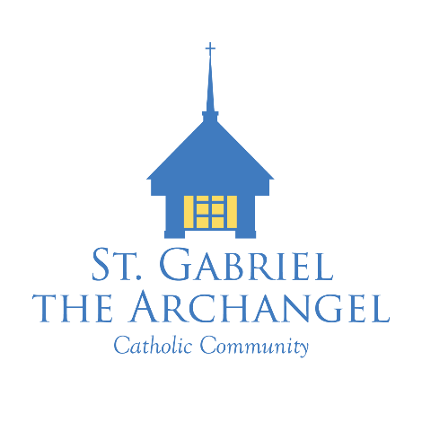
Faith Formation Office (CFC)
900 Geiger Street | Neenah, WI 54956 | 920-725-0660
Victor Meschi
Grades 7-10 and Confirmation
vmeschi@smcatholicschools.org

Jenny Schneider
Grades 1-6, Reconciliation and First Communion
jschneider@smcatholicschools.org

2024/2025 Class Dates
Grades 9 and 10
7:15 – 8:45

September 18th – Small Group Leader Night
September 25 6:00 PM Kickoff Mass with Ice Cream Social to follow

October 2
October 9
October 16
October 23
October 30 Invited to MS/HS Vocations Fair – More info TBA

November 6
November 13 Small Group Night
November 20
November 27 No Class – Happy Thanksgiving!

December 4 Advent Celebration – All grades, bring your Families! (6:00) PM
December 11 6:00 – Reconciliation Service
7:15 – Service Project & Small Group Night
December 18

January 1 Holy Day of Obligation No Class
January 8
January 15
January 22
January 29

February 5 Class time at 7:30-8:45 for this week.
February 12
February 19
February 26

March 5 Ash Wednesday – Everyone is invited! 5:30 Activity followed by 6:00 Mass
March 12 Lenten Prayer Night – with Reconciliation Opportunity
March 19
March 26

April 2 No Class/Spring Break
April 9 Q&A Night/Church Tour: All about the Mass
April 16 No Classes to attend Holy Week Liturgies
Sun April 20 EASTER SUNDAY
April 23 Final Day of Class

Sun May 4 Servant Sunday at 10:00 Mass

