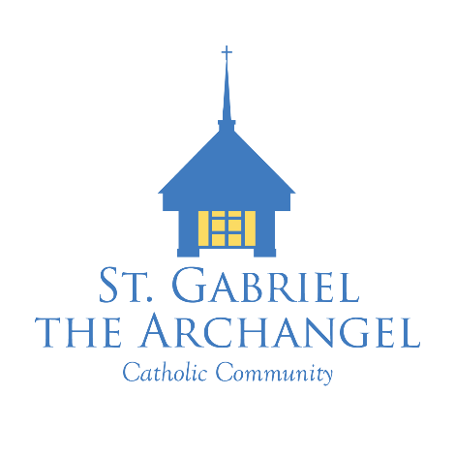
Faith Formation Office (CFC)
900 Geiger Street | Neenah, WI 54956 | 920-725-0660
Victor Meschi
Grades 7-10 and Confirmation
vmeschi@smcatholicschools.org

Jenny Schneider
Grades 1-6, Reconciliation and First Communion
jschneider@smcatholicschools.org

2024/2025 Class Dates
Grades 9 and 10
7:15 – 8:30

(Sun) September 21 – Catechetical Sunday
September 10 Small Group Leader Night
September 17 6:00 PM Kickoff Mass with Ice Cream Social to follow
September 24 Tentative: Fox Valley Religious Ed – Guest Speaker at {TBA}

October 1
October 8
October 15
October 22
October 29 All Saints Day Party

November 5
November 12
November 19
November 26 – No Class – Happy Thanksgiving!

December 3 – Advent Celebration – All grades, bring your Families! (6:00PM)
December 11 – Class at 7:15
Advent Reconciliation Service – 6:00 PM
December 18 Last Class of Semester

2024/2025 Class Dates
Grades 9 and 10
7:15 – 8:30

Thursday January 1 Holy Day of Obligation - No Class
January 7
January 14
January 21 5-Parish Class retreat – Held at St. Mary Middle School
January 28

February 4
February 11
February 18 Ash Wednesday – All are invited! Join us at 5:30 followed by a 6:30 Mass.
February 25

March 4
March 11
March 18 No Class – Winter Break
March 25

April 1 No Class – Spring Break
April 8
April 15
April 22
April 29 Final Class

